|  |  |  |  |  |  |
| --- | --- | --- | --- | --- | --- |
|  |  |  |  |  | logo1.png |

|  |  |  |  |
| --- | --- | --- | --- |
| Course Name | | Graphic designing with canva | |
| College Name | | Mangayarkarasi College of Arts and Science for Women Paravai, Madurai - 625002 | |
| College Code | | MKU251 | |
| Skill Offering Id | |  | |
| Project Title | | Create a social media post | |
| Project Submitted To | | Madurai Kamaraj University ( Naan Mudhalvan Scheme(TNSDC)) | |
| Year | | 2023 | |
| Department | | B.A English Literature | |
| Semester | | 5 | |
| Group Number | | 2 | |
| Total Members of the Group | | 4 | |
| Group Members Details | | | |
| Name of the Member | University Register. No | | Student NM ID |
| Gayathiri .M | MKU251C1A7415 | | E18636AA3FB41E9B17A44373DEF922D7 |
| Anitha.B | MKUC1A17408 | | 29CAB4C5B433AAF80D1492324EE2438A |
| Ajitha.A | MKUC1A17407 | | D437EE602173580801D4F516B3C11320 |
| Abinaya.R | MKUC1A17405 | | 515526E9FD2F6989921402E9AE23B211 |
|  |  | |  |
| Under the Guidance | |  | |
| SPOC | | Ms.P.UMADEVI | |

**Analysing Housing Prices in Metropolitan areas in India**

1. **Introduction.**

***1.1 Overview***

**Social media marketing can help increase brand awareness, helps to connect with the customers. Creating good social media content requires a plan. A social media content plan is part of your overall marketing strategy; it helps you effectively plan the types of content you post on different social media platforms depending on your audience.**

**Social media has a broad and significant impact not only on online activities, but also on offline behavior and life in general. Social media can play an important part in influencing decision making and is therefore regarded as a top advertising platform by major brands.**

***1.2 Purpose***

**Main purpose is to increase brand awareness and visibility. With social media, one can share information and ideas in a variety of ways. More and more, social media are being used for marketing purposes. Social media can also serve as personal learning tools Maybe the most powerful element of social media is their interactive nature. Social media break the traditional barriers of time and distance between people.**

1. **Problem Definition and Design Thinking**
   1. Empathy Map 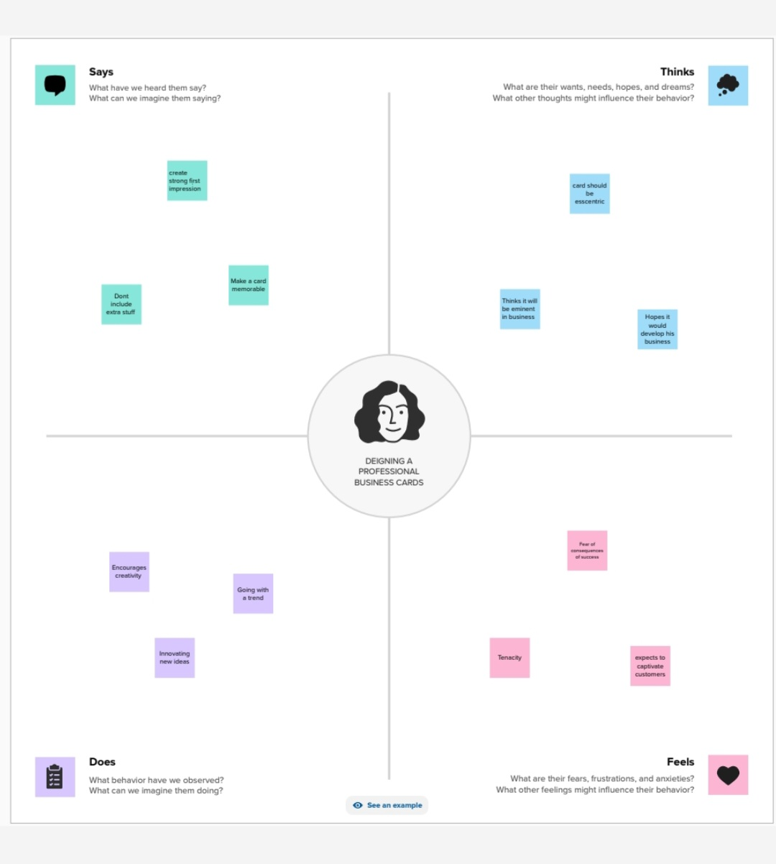

**2.2 ideation and Brainstorming map**

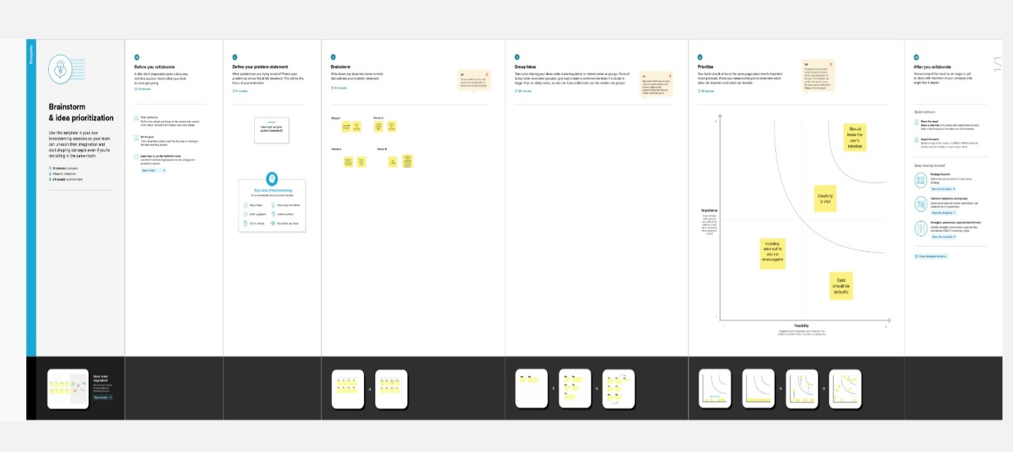

**Milestone 1**

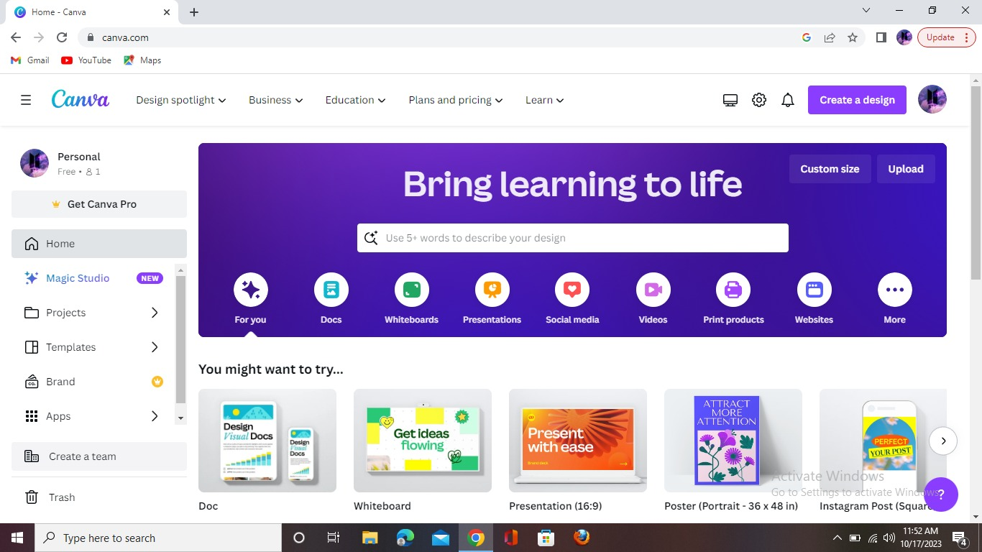

**Milestone 2**

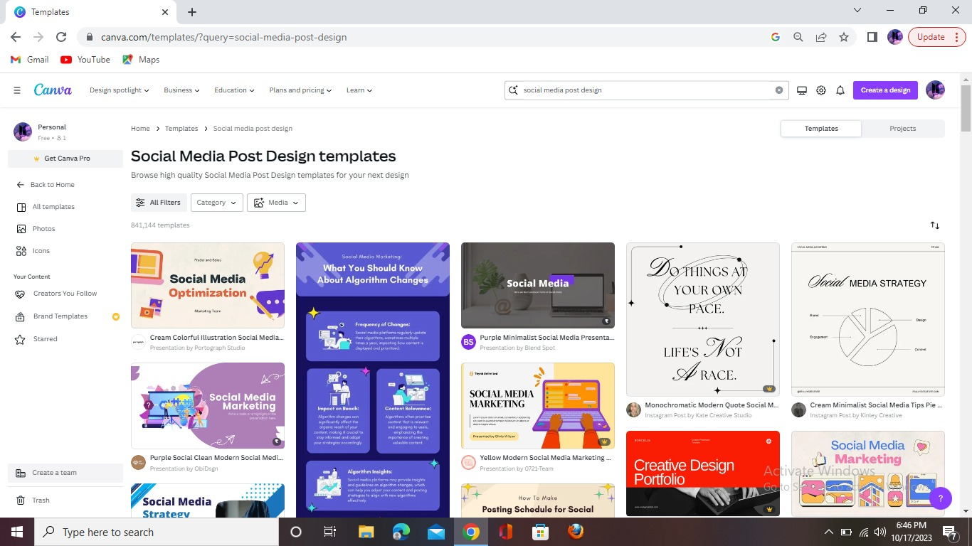

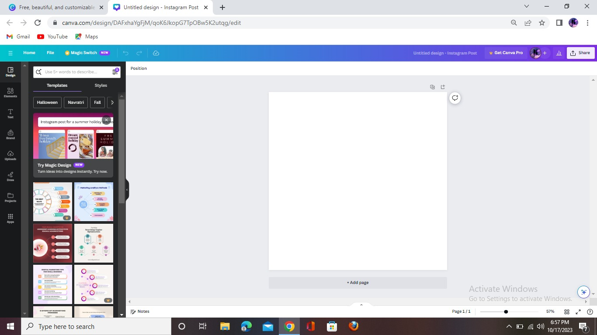**Milestone 3**

**Milestone 4**

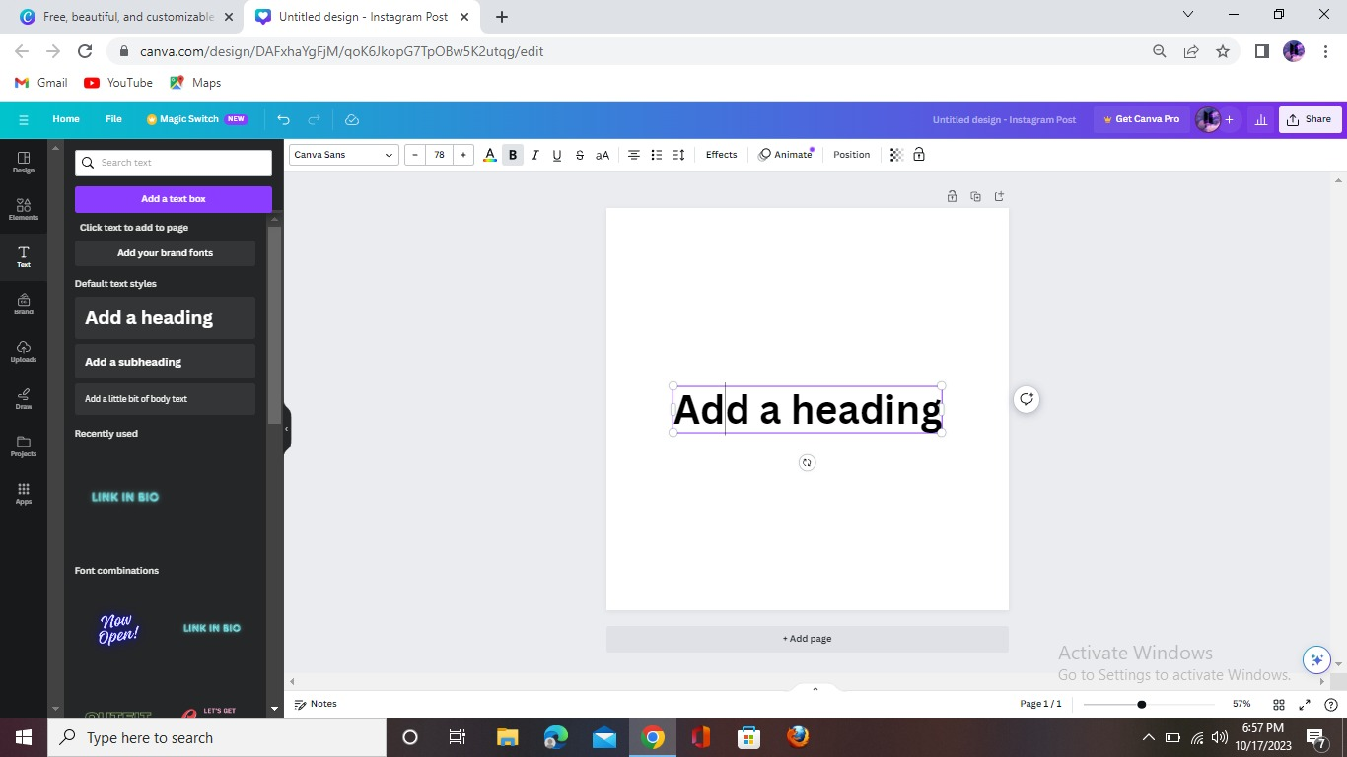

**Milestone 5**

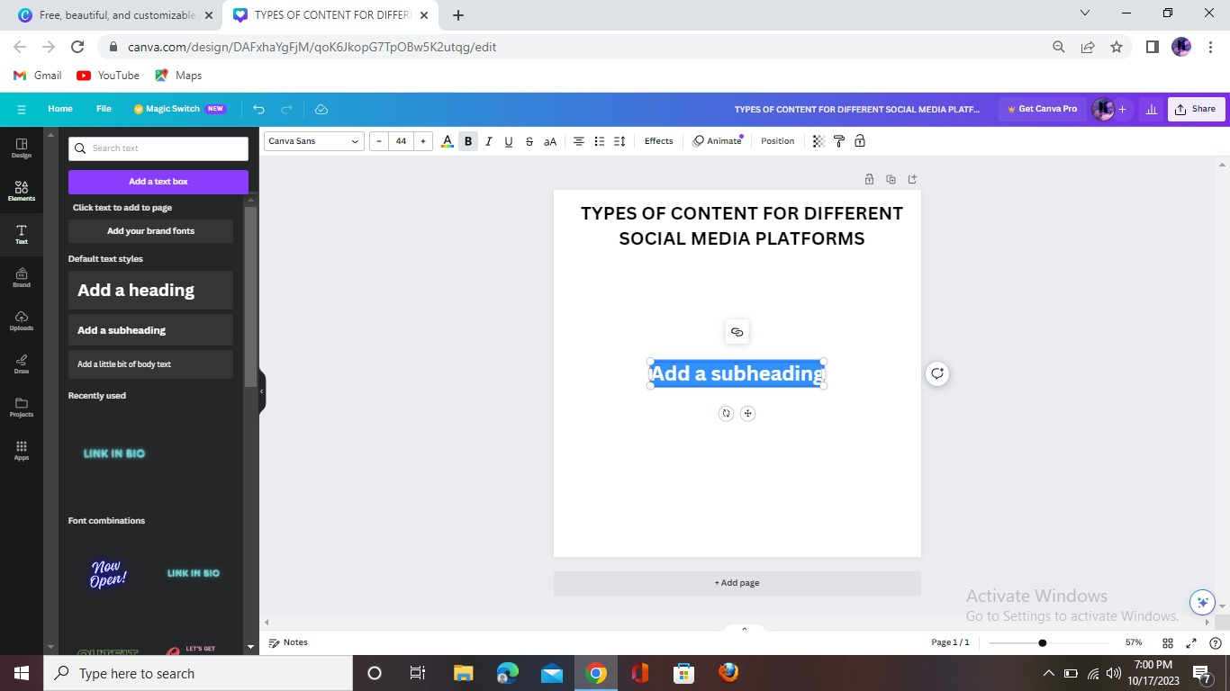

**Milestone 6**

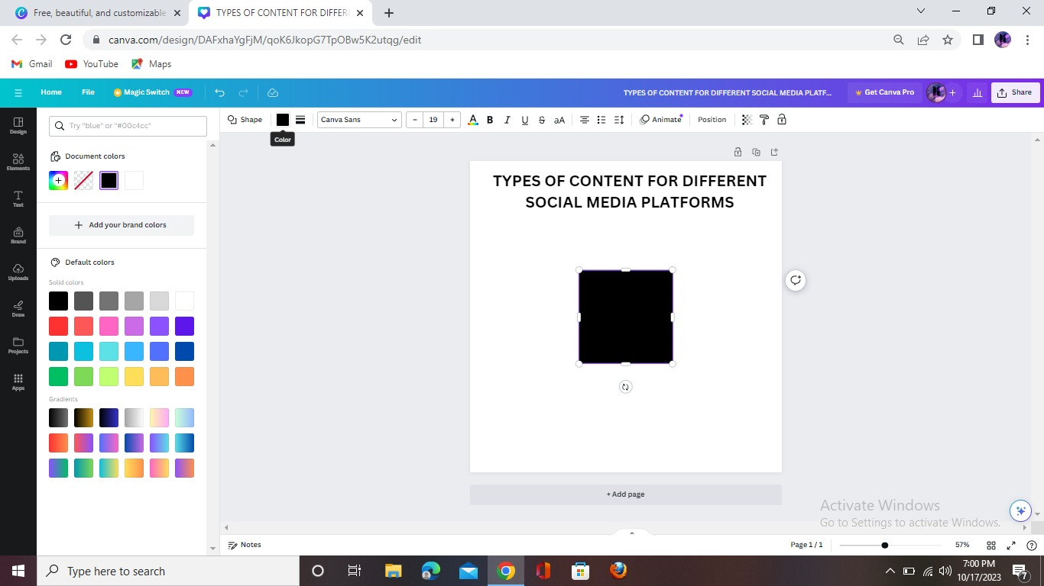

**Milestone 7**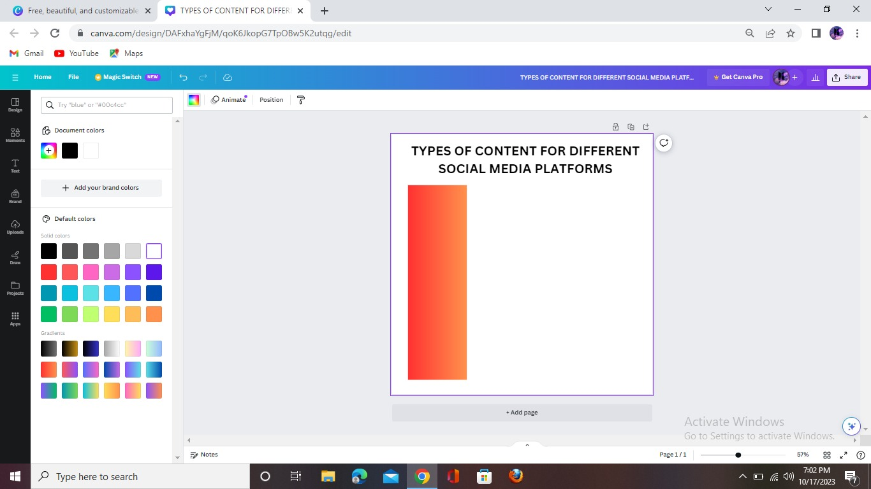

**Milestone 8**

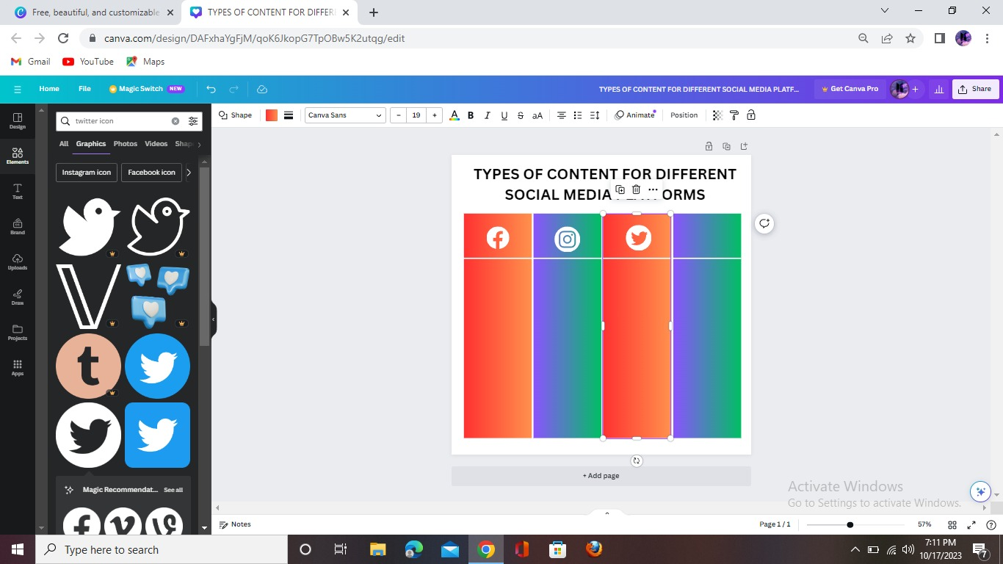

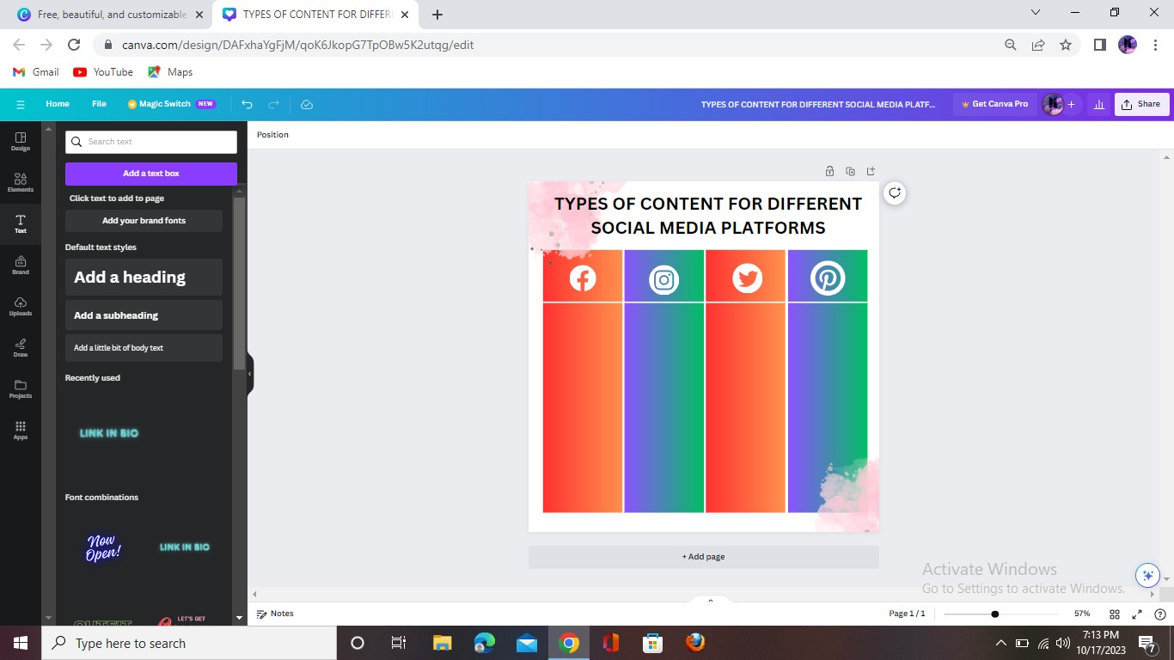**Milestone 9**

**Milestone 10**

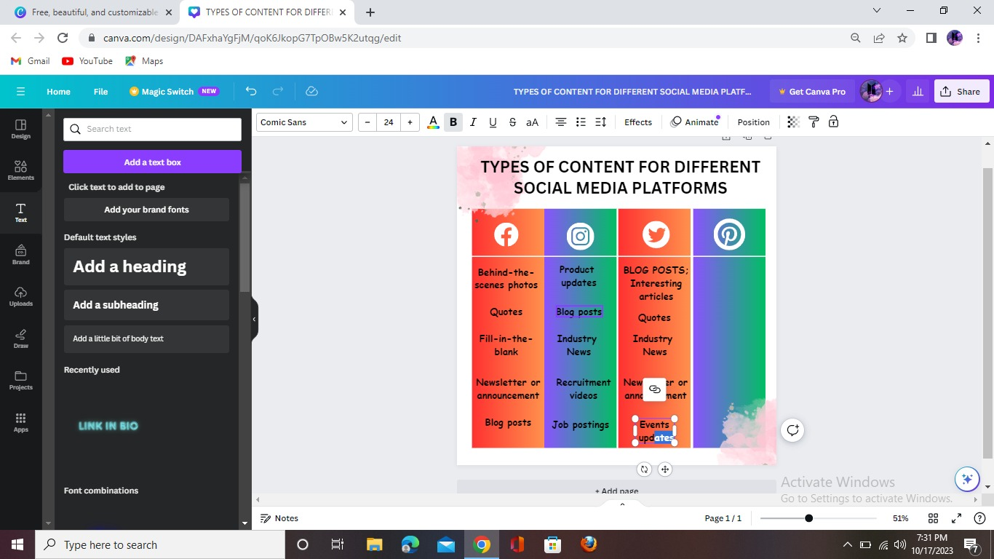

**Milestone 11**

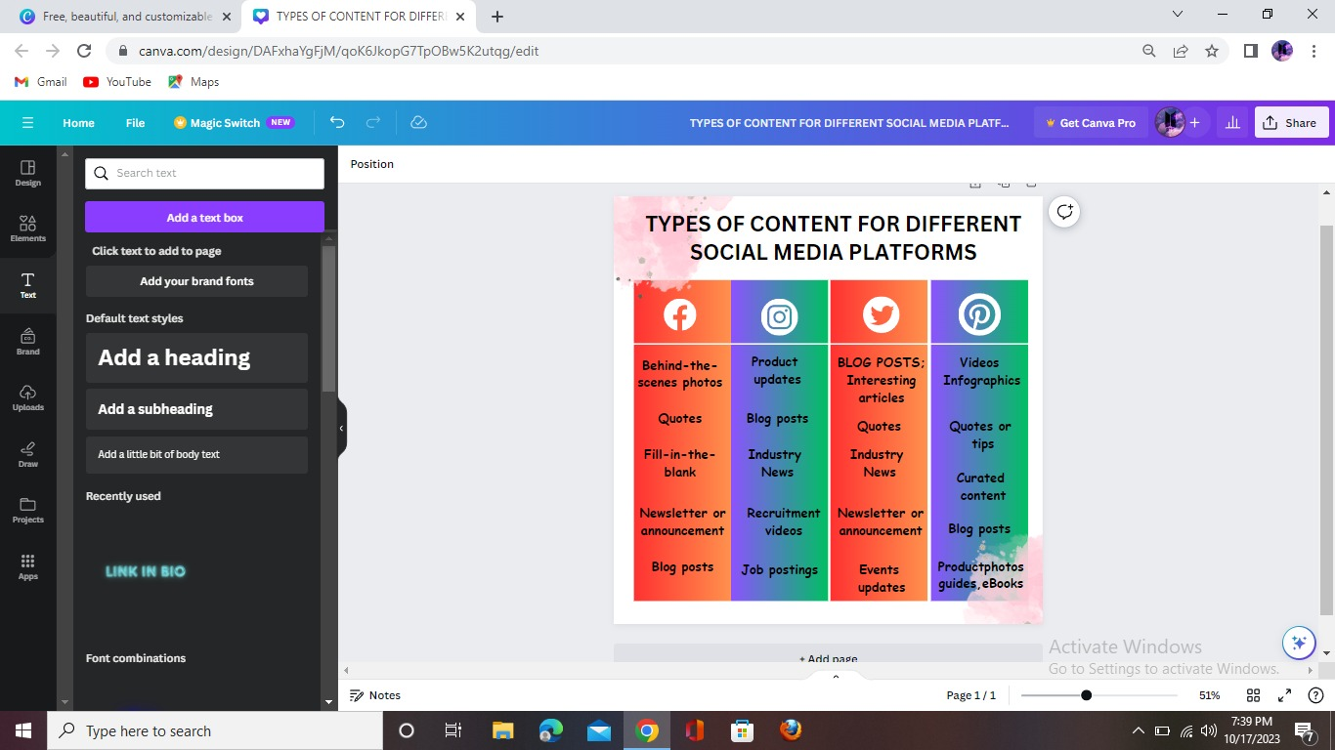

**Output**

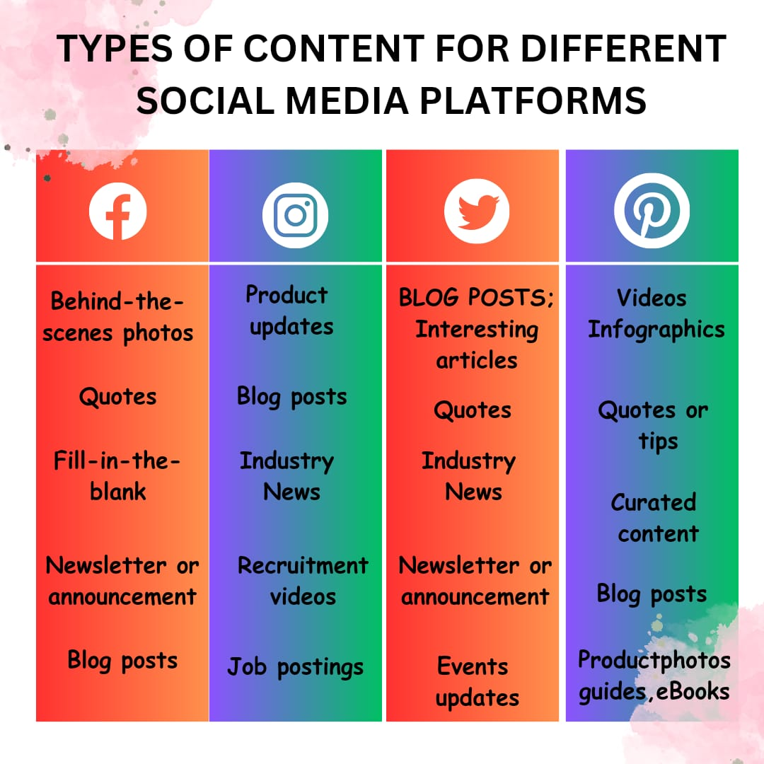

**Advantages of social media**

**Creates Awareness**

There have been numerous instances where social media platforms have played an important role in raising awareness and revolution, including the Libyan Revolution, Arab Spring, Occupy Wall Street, and the Ukrainian Revolution, to name a few. We can use these global platforms to raise your voice against issues and educate people about various causes such as environmental concerns, social issues, and so on.

**Education**

In the subject of education, social media has shown to be effective. It facilitates learning by bringing together educators and professionals from all around the world with students.

**Share Anything with Others**

Social media is the finest place to share everything you want. It may be a song, a poem, an artistic masterpiece, a delectable dessert dish, or anything else. It enhances and shows a person’s creativity while also allowing them to reach millions of consumers.

**Disadvantages of social media**

**Hacking on Social Media**

Hacking is the most severe drawback of social media, and it affects the majority of people. Hacking is a prohibited action, and it is the act of gaining access to another person’s personal and limited information.

**Cyberbullying**

One of the worst aspects of social media is cyberbullying, which is one of the top disadvantages of social media. Bullying that takes place on social media platforms is known as cyberbullying. The majority of people use false social media accounts to tease others.

**Serves as a Distraction**

You have an urge to check your phone for notifications and messages whenever you wake up or go to sleep. Distractions from social media have hampered both our work and our time. Moreover, everyone is racing to gain the most Facebook or Instagram followers, leaving their abilities and strength to achieve something in life behind.

**Future scope**

Social media Develops sharable content and advertorials.

It Establishes social media platform presence

Encourages feedback from the customers through contests and surveys. The digital marketing industry is ever-growing and brings about more opportunities for career growth.